HOTEL MANAGEMENT SYSTEM

**Submitted by**

**Mannu Thomas (35)**

**Manisha Mathew (34)**

**Nikitha A Paul (42)**

**Neha Suresh (40)**

**Aim**

This project aims in designing and developing an organized database management system, which can easily manage all the operations and data of the hotels.

**Use case diagram**

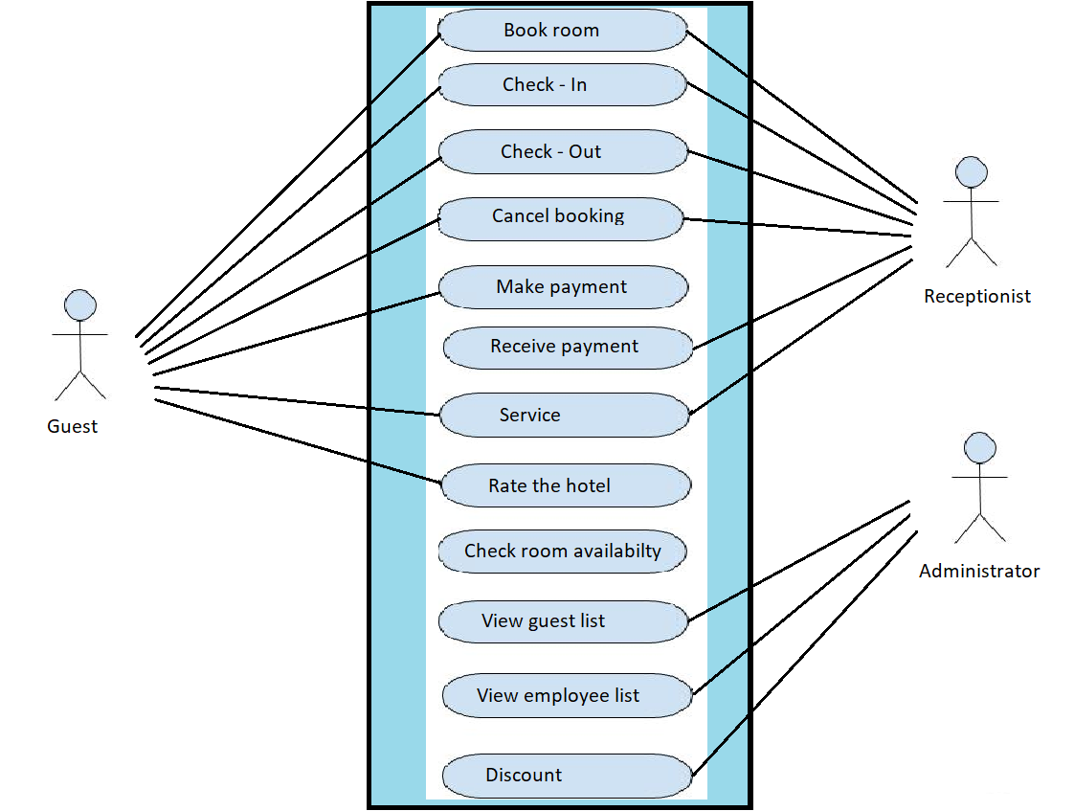

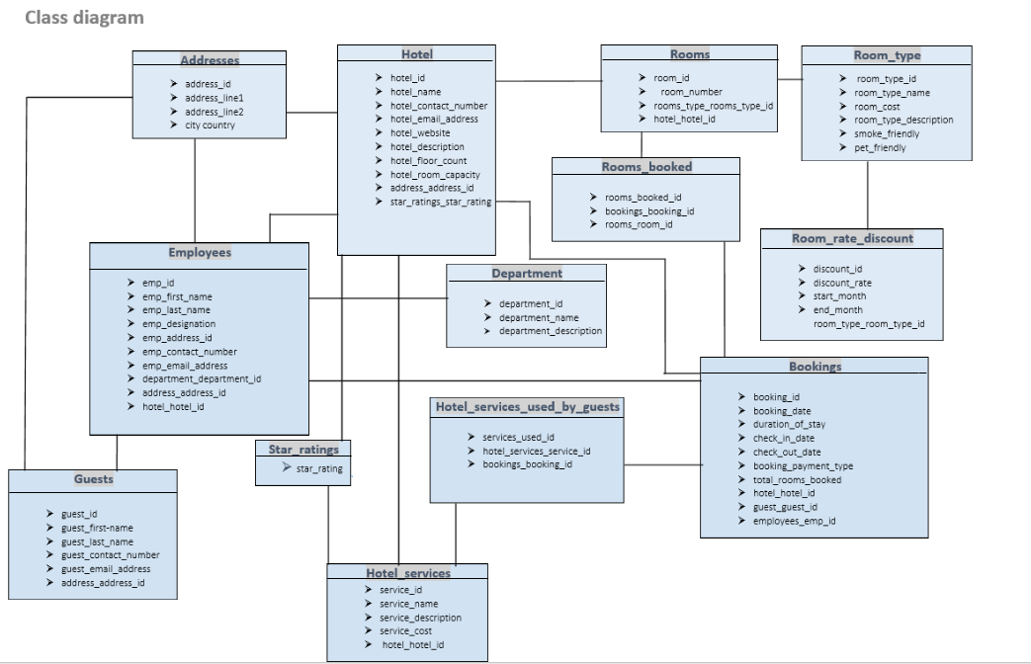

**Module Description**

This is a simple database to manage the logs of a hotel. This database helps us to manage individual definitions for accommodation characteristic by room types, services, etc. It enables commitment and allotment control of rooms and other services.

**Bookings Module**

This module contains data about the bookings made for rooms. The primary key for this table is booking_id. The keys hotel_hotel_id, guests_guest_id, employees_emp_id are associated with hotel, guests, employees tables respectively. It stores the check in and check out details, duration of stay,etc. The receptionist can check for room availability.

**Department Module**

This module contains the data about the different departments of the hotel. The primary key is department_id, which creates a one-to-many relationship with the employees table. The administrator can view the department status of an employee.

**Employees Module**

This module consists of data related to the employees. The primary key is employee_id. The keys service_id, address_id and hotel_id are associated with department, addresses, and hotel table respectively. The administrator can view the employee list.

**Addresses Module**

This module defines the information about the address of guests, hotels, employees. The primary key is address_id. It maintains one-to-one relationship with tables, hotel, employees and guests.

**Guests Module**

This module has the data about the guests that check in to the hotel. The primary key is guest_id. Address_id has one-to-one relationship with addresses table. The guests can check in and check out of the hotel. They can select the services they want and can even rate the hotel.